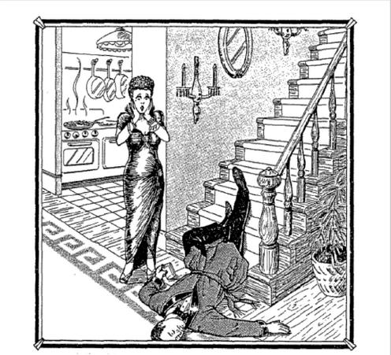

Slip or Trip?

At five-feet-six and a hundred and ten pounds, Queenie Volupides was a sight to be hold and to clasp. When she tore out of the house after a tiff with her husband, Arthur, she went to the country club where there was a party going on.
She left the club shortly before one in the morning and invited a few friends to follow her home and have one more drink. They got to the Voupides house about ten minutes after Queenie, who met them at the door and said, “something terrible happened! Arthur slipped and fell on the stairs. He was coming down for another drink—he still had the glass in his hand---and I think he’s dead. Oh, my God—what shall I do?!”
The Autopsy conducted later concluded that Arthur had died from a wound on the head and confirmed that he’d been drunk.

Your group is an investigative team that must determine what may have happened. You can either agree or disagree with Queenie’s version.

- Do you think Queenie is telling the truth?
- Find all the evidence you can that indicates whether or not queenie is telling the truth. Make a list of all the evidence. Evidence includes concrete, observable information, personal testimony, written documents, and material objects and their condition or appearance.
- Next explain how each piece of evidence supports your claim that Queenie is or is not telling the truth. Each explanation will be a generally accepted rule (warrant), which may begin with a phrase such as “As a rule…” If other members of your team disagree with you, find evidence that will convince them.
- Be prepared to explain why your evidence supports your case.

Evidence | Warrant (rule)

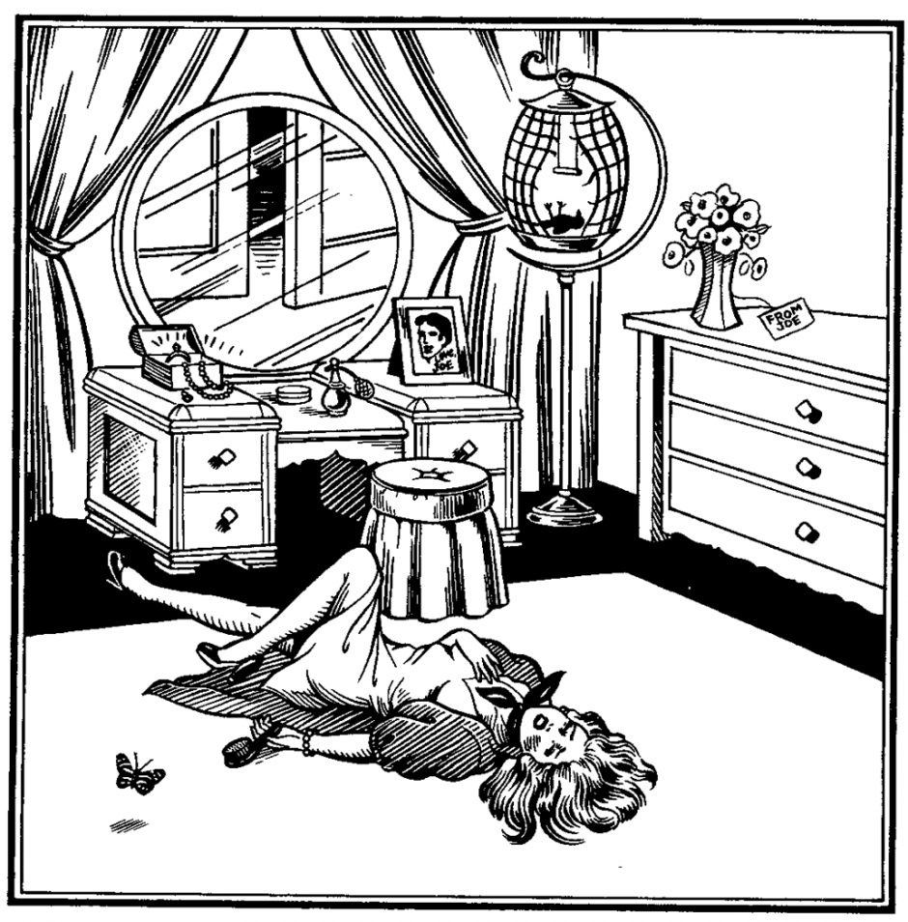
Amy LaTour’s body was found in her bedroom last night, as shown, with her pet canary strangled in its cage. Hery Willy and Joe Wonty, her boyfriends; Louis Spanker, a burglar, known to have been in the vicinity; and Celeste, her maid, were questioned by the police.

Based on the evidence found at the scene, who killed Amy?
Evidence | Warrant (rule)

Based on these data and rules, what is your claim?:

