Maine Gov. LePage says he will not speak to reporters anymore
Eliza Collins, USA TODAY 7:01 p.m. EDT August 31, 2016
1.0k Shares
http://www.usatoday.com/story/news/politics/onpolitics/2016/08/31/paul-lepage-maine-reporters/89652732/
Play Video
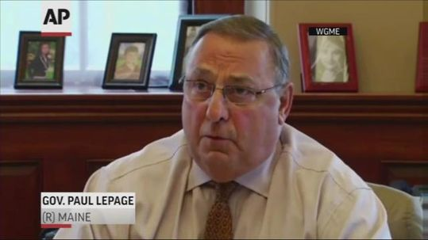

Maine Gov. Paul LePage is addressing questions about his fitness to serve and is vowing that he won't resign. This comes and lawmakers and voters call for him to step down. (Aug. 31) AP
Gov. Paul LePage, while speaking to reporters, announced that he would never speak to the press again.
On Wednesday, the Maine governor apologized for threatening a state representative last week. But he then said there was someone else who should apologize as well — the reporter who asked him about Democratic Rep. Drew Gattine in the first place.
“After speaking with Rep. Gattine, I think that the reporter who put the mic in my face owes the people of Maine an apology as well. Because (Gattine) never called me racist,” LePage told reporters, according to video from a Maine News 13 reporter Wednesday. “He said I made racially (charged) comments. Maybe, in my mind, it is semantics. But in his mind, after talking to him, it was clear that there was a real difference. Fine.”
LePage said he took the media's “bait,” but he called the fact that the reporter appeared to suggest Gattine called LePage a racist was a “cheap shot.”
How does he plan to avoid incidents like this in the future?
“I will no longer speak to the press ever again after today,” LePage said. “And I’m serious. Everything will be put in writing. I am tired of being caught — the gotcha moments.”
“You folks live in a seven-second fiction world. I live in 24-hour reality,” he continued.
LePage has faced scrutiny following the voicemail attack on Gattine, which was prompted after a reporter appeared to suggest that Gattine had called LePage racist.
Gattine said he never called LePage racist, according to The Portland Press Herald, which also posted audio of the voicemail from last Thursday.
“Mr. Gattine, this is Gov. Paul Richard LePage, I would like to talk to you about your comments about my being a racist, you (expletive). I want to talk to you. I want you to prove that I’m a racist. I’ve spent my life helping black people and you little son-of-a-b----, socialist (expletive). I need you to, just friggin, I want you to record this and make it public because I am after you. Thank you.”
After leaving the voicemail, LePage told reporters that he had left the message and that he wished it was 1825 so the two could duel.
“When a snot-nosed little guy from Westbrook calls me a racist, now I’d like him to come up here because, tell you right now, I wish it were 1825,” LePage said, according to the Press Herald. “And we would have a duel, that’s how angry I am, and I would not put my gun in the air, I guarantee you, I would not be (Alexander) Hamilton. I would point it right between his eyes, because he is a snot-nosed little runt and he has not done a damn thing since he’s been in this Legislature to help move the state forward.”
There has been pressure for LePage to resign following the outburst. On Tuesday, he told a Maine radio station “maybe it’s time to move on.” But by Wednesday he had decided he would stay in office.
“Being called a racist was a horrible thing for me. It was enormously hurtful. It hurt my family. I will not resign, though,” LePage said Wednesday.

- Write a response to LePage. If you could talk to him about this situation, what would you say?
- Write one level 3 question brought up by this article and respond to it.
- Do you think the media instigates fights between politicians or other famous people? Explain your answer.
- Should people in office censor themselves when speaking to the public? Why or why not?

