Divided by Race, United by Pain

http://www.nytimes.com/2016/07/10/opinion/how-america-heals-after-dallas.html
Frank Bruni JULY 8, 2016
Continue reading the main storyShare This Page
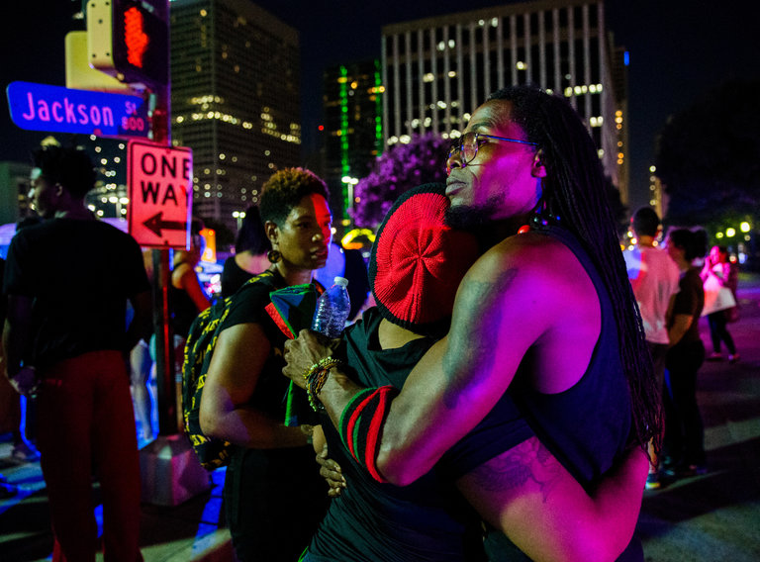
Protesters reacting to the shooting in Dallas on Thursday night.CreditAshley Landis/The Dallas Morning News, via Associated Press
THERE aren’t any ready answers for how to end this cycle of bloodshed, these heart-rending images from Louisiana and Minnesota and Texas of a country in desperate trouble, with so much pain to soothe, rage to exorcise and injustice to confront.
But we have choices about how we absorb what’s happened, about the rashness with which we point fingers. Making the right ones is crucial, and leaves us with real hope for figuring this out. Making the wrong ones puts that possibility ever further from reach.
So does a public debate that assigns us different tribes and warring interests, when almost all of us want the same thing: for the killing to cease and for every American to feel respected and safe.
We have disagreements about how to get there, but they don’t warrant the inflammatory headlines that appeared on the front of The New York Post (“Civil War”) or at the top of The Drudge Report (“Black Lives Kill”). They needn’t become hardened battle lines.
“We have devolved into some separatism and we’ve taken our corners,” Malik Aziz, the deputy chief of police in Dallas, said in an interview with CNN on Friday. “Days like yesterday or the day before — they shouldn’t happen. But when they do, let’s be human beings. Let’s be honorable men and women and sit down at a table and say, ‘How can we not let this happen again?’ and be sincere in our hearts.”
“We’re failing at that on all sides,” he concluded, expressing a sentiment uttered by public officials black and white, Democrat and Republican, in laments that drew on the same vocabulary.
Separate, divided: I kept hearing those words and their variants, a report card for America as damning as it was inarguable.
Continue reading the main story
Separate, divided: I kept seeing that in pundits who talked past and over one another, in a din that’s becoming harder and harder to bear.
Separate, divided: I kept thinking of Donald Trump and how he in particular preys on our estrangement and deepens it.
On Friday he didn’t, putting out sorrowful, thoughtful messages on Twitter and Facebook and announcing his postponement of a speech on economic opportunity that he had been scheduled to deliver. He was otherwise silent, and while that was entirely out of character, it was wholly in line with the shock and confusion that Americans were feeling.
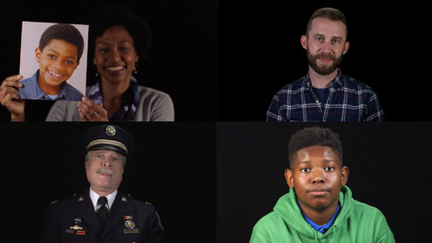
OPEN INTERACTIVE FEATURE

Hillary Clinton wrestled with that confusion in an interview with CNN’s Wolf Blitzer, stressing, “We can’t be engaging in hateful rhetoric.” Asked if and why she’d be better at dealing with race relations than Donald Trump would, she declined to disparage him. This wasn’t the moment for that.
We can’t keep falling into the same old traps. We can’t keep making hasty conclusions, faulty connections. Predictably, there was a recurrence of talk after the killings of five police officers in Dallas late Thursday night that this was the fruit and fault of the Black Lives Matter movement and that cries of police misconduct equal a bounty on police lives.
That was a willfully selective interpretation of events. It ignored an emerging profile of the suspected gunman as someone who acted alone, not as the emissary of any aggrieved group.
It ignored how peacefully the protest in Dallas began and how calmly it proceeded up until shots rang out. Black and white stood together. Civilians and cops stood together. Those cops were there precisely because they’d been briefed on the demonstration and brought into its planning. They were a collaborative presence, not an enemy one.
“We had police officers taking pictures with protesters, protecting them, guarding them, making sure they was getting from one point to another,” Aziz recalled.
And their instincts amid the gunfire weren’t to flee for cover but to run toward its source and to hurry demonstrators out of the way. If we don’t pay full tribute to that, we’ll never get the full accountability from police officers that we also need, and we’ll never be able to address the urgent, legitimate demands at the heart of the Dallas demonstration and others like it.
“We’re hurting,” Dallas’s police chief, David Brown, said during a news conference on Friday morning. “Our profession is hurting.”
He’s black. So are many other officers on the Dallas force, a diverse one with a good record. And he implored everyone to remember that these men and women, in Dallas and elsewhere, “literally risk their lives to protect our democracy.”
“We don’t feel much support most days,” he continued. “Let’s not make today most days.”
That appeal was all the more poignant for how it united police and protesters in a desire that no sweeping, damning judgments be made about a whole class of people; that such prejudice be resisted; that such cynicism be renounced.
We must be openhearted and coolheaded that way.
But we have to be honest, too, and not shrink from the ugliness laid bare by technology and social media — by the footage of the police pumping bullets into Alton Sterling in Baton Rouge, La., on Tuesday and of Philando Castile bleeding and dying beside his girlfriend, Diamond Reynolds, on Wednesday in Falcon Heights, Minn. Over and over, Reynolds says “sir” to the police officer who shot Castile and whose gun is still visibly pointed toward the interior of the car where both she and her 4-year-old daughter, Dae’Anna, sit. It’s a shockingly intimate portrait of disbelief and helplessness.
On Friday morning, Reynolds appeared on CNN and insisted that her story not be seen in isolation. “It’s about all of the families that have lost people,” she said.
“This thing that has happened in Dallas, it was not because of something that transpired in Minnesota,” she continued. “This is bigger than Philando. This is bigger than Trayvon Martin. This is bigger than Sandra Bland. This is bigger than all of us.”
She added that Friday was Dae’Anna’s graduation from preschool, that Castile was supposed to be there, and that his absence would be hard on the little girl.
Reflecting on Castile’s death, Gov. Mark Dayton of Minnesota asked: “Would this have happened if those passengers would have been white? I don’t think it would have.”
It’s an important question, a defensible guess, and we need to be able to hear and express both without the instant commencement of political warfare, without superimposing particular causes and constituencies over the narrative, as if every new development and every next death were a bludgeon to be wielded.
There’s only one cause here: taking the appropriate steps — in criminal justice, in police training, in schools, in public discourse — so that each of us goes about our days in as much peace as possible. And the constituency for that is all of America.
Among the important choices we’re making is whom to listen to. There are voices out there — too many of them — that seek to inflame. There are others that don’t. Three from Dallas stood out.
One was that of Mayor Mike Rawlings, who lamented how racial issues “continue to divide us.”
“This is on my generation of leaders,” said the mayor, who is white. “It is on our watch that we have allowed this to continue to fester, that we have led the next generation down a vicious path of rhetoric and actions that pit one against the other.”
Another voice was that of Erik Wilson, the deputy mayor pro tem of the city, who is black. “No conflict has ever been solved with violence,” he told CNN. “It’s always been solved with conversation. And that is something that we need to focus on.”
And then there was Deputy Police Chief Aziz, who is also black. Referring to nationwide instances of excessive police force, he said, “We should be held accountable, and that is what we have a criminal justice system for.”
But of equal importance, he said, was “a real dialogue with the community that we can no longer be separate. We can’t divide ourselves.”
Separate, divided: those words again. They’re our curse right now. Must they be our fate?

1. What is the author’s argument?
2. This is an op-ed, which means that the author is trying to persuade you of his point. What strategies does he utilize to convince you of his point?
3. What do you think about this issue?
4. Ask your own level three question and answer it.

