4 Steps To Writing Truly Scary Horror
Posted by Jeff Provine | How To Write, Worldbuilding | 1 |

Editor’s Note: The spooky season is upon us, so we thought we’d republish this how-to guide from October 2013 for those of you who missed it the first time around. Every day this month, Jeff is posting a short scary story on his Facebook page — click here to check them out and get a glimpse of his tips in action!

With Halloween fast approaching, one of storytelling’s most popular genres prepares to take center stage: Horror. We can imagine early writers sitting around campfires spinning tales of comedy or romance or epic struggle, but, just like today, they would have also told tales to bring thrilling chills to their audience and scare nightmares into them.
How do these masters do it? From Edgar Allan Poe to HP Lovecraft to Stephen King, they all play upon the minds and faint hearts of the audience by creating worlds readers half-create themselves.

1. Connect with Readers’ Fears
There’s a reason “It” is a clown and a giant spider: clowns and giant spiders are terrifying!
A good way to begin writing a Horror story is to determine what it is that terrifies people. It can be as easy as an out-of-control car, a creepy neighbor, someone in a mask, or, to quote Family Guy, a lamp monster.
Ghosts and monsters are clear examples. Both come from beyond the readily known. A ghost itself represents the great unknown of death, and the thought that something can come out of that unknown and act, even potentially injure, breaks the comfortable bubble of the human mind pretending it understands the universe. A monster, too, comes from the unknown: the shadows in the closet, the crevices under the bed, or the darkness in the woods where elders said never to go. No one knows what the monster is exactly, so no one knows how to fight it. It is an unstoppable force that will overwhelm and kill.
Lovecraft revolutionized the monster by showing mankind’s feeble place in the universe. On a more day-to-day level, there are still things that unnerve us in their unpredictability. Mental illness, disease, robbery, attack by someone we don’t know (or someone we do), all these destroy our shells and leave us horrified and exposed. Ask yourself, what scares you?
I think this dog’s greatest fear is about to be yarn wigs if it’s not already.

2. Build through Pacing
“Jump scares” are valuable tools in movies, but something suddenly popping doesn’t quite work as well in written word. There are times to show a shocking attack or a monster popping out, but to make the story really roll, you have to build it. As the story-world comes together, the reader’s mind creates as much as the words on the page.
Start off the story and even scenes showing the situation at hand. Misery shows a writer who is looking to reinvent himself. That’s an interesting enough story on its own; it has plenty of room for drama and characterization. But when he suddenly comes under the mercy of the deranged fan who refuses to let him, then it gets scary. Then there’s Marion from Psycho, stealing money from a bank and hiding out in an old motel. The motel owner is creepy, and he grows creepier and peepier until the absolute unthinkable happens.
To have your readers sympathize with the protagonists in Horror, show their lives before it comes upon them. There are plenty of terrible zombie or slasher movies where unsympathetic people are out doing something dumb and suddenly get killed. Half of the time, we end up laughing at them and saying, “Yep, had it coming!”
Showing people already living their lives with their own worries and hopes, just like our own, gives the reader a better connection. When the monster appears, the reader is just as horrified as the protagonist. Poltergeist has a loving family hoping to see days of prosperity after plenty of hard work. We don’t want to see stuffed clowns and disembodied forces hurt them. We are willing to invest our emotions and journey with them to see the little girl rescued from a force we don’t even see.

3. Use the Senses (But Leave Room)
To really give the readers the desired scare of prickled hairs with hearts pounding and fingers trembling as they try to turn the page, the author needs to use sensory description. Paint the scene and draw the audience in with not only visuals of the horror, but hearing, touch, even taste and smell.
“A creature sits in the shadow” becomes all the more horrifying when the writer tells of its “rasping, staggered breathing from ill-formed lungs.” It “stinks of putrid rot, the foul air of refuse and sewage” burning the inside of the nostrils. As its tentacles slither over the wooden floor, they are cold and wet, unyieldingly strong yet spongy, oozing black pus.
While giving details is a great way of supplying description, avoiding precise visuals gives the reader’s imagination to fill in the gaps with something creepier than words could ever convey. Many classic Horror movies do their best work never actually showing the monster or at least saving it for one shocking reveal. Alien has a famous deleted scene of thexenomorph in its entirety as a lanky guy in a suit doing a hilarious walk. The alien is far more terrifying when all we see are flashes of the creature circling in the air ducts or a close-up of its horrid claws.
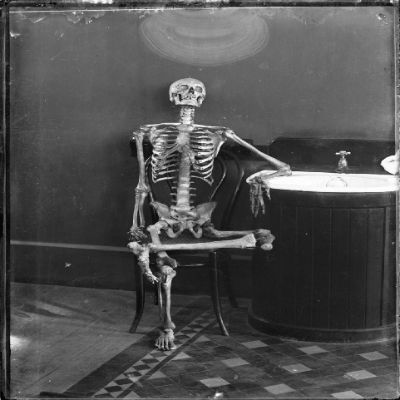
Humans are primarily visual creatures, and if we take away specifics, the mind floods in with possible realities. When there’s a crash in the dark, it’s most likely the cat knocking over a stack of books, but we immediately think of a deranged burglar bursting in or some wretched creation of pure evil crawling out of the Netherworld to drag us from our beds into a mind-crippling eternity of torture.
Yeah…not as scary as the sound of rattling bones behind a closed door.

4. Show the Emotions
Like any genre, Horror has a certain mood and word choice that flows through it. Because the passion of the reader is so important to Horror, the wording must suit. Romance has its sultry, tantalizing purple prose, and Action its fast-hitting, short-cut sentences, but Horror crawls and slithers until it suddenly strikes to leave its audience screaming.
Poe’s “The Raven” gives an excellent taste of poetic, horrifying language. “Once upon a midnight dreary, while I pondered, weak and weary” tells us that the protagonist is up late, tired but unable to sleep. It gives so much more with the word “weary” than “tired.” His soul is exhausted, worn down to the point even sleep is not restful. Then, of all things, a bird bursts into his room and begins talking to him. Or, as Poe stated more horrifically, “Quoth the Raven, ‘Nevermore.’” In any other wording it would be ridiculous, but the Raven’s quote has haunted us for over 150 years.
Guiding the emotions of the reader is the skillful art of the true master of Horror. Anyone can conjure gory scenes or talk about a monster, but a great writer captures the readers by connecting them with characters who face an enemy beyond understanding. Steer the emotions with carefully chosen spooky words, and read them aloud to test terror. If your neck prickles and your arms shiver with scales of goosebumps, you’re on the right track.

