Jewish Faith
Jews have always been disliked by Christians, simply for the reason that they believe something different than them. Interestingly enough, however, the two religions are not that different. In fact, they stem from the same religion—the first Christians were Jewish. They believe in the same God, however they do not believe that the Son of God has come yet and so are still waiting. Their holy book, called the Talmud, is extremely similar to the Christian Old Testament, with some minor variations for rituals and holidays. The “priests”, called Rabbi or Rebbe, hold services in the synagogue, the Jewish place of worship, much like Christian churches. The services are often held on Friday nights, since Saturdays are Jewish holy days called Sabbaths. Just as Christians do not work on Sundays, Jews do not work on Saturdays. Often these services include the help of others who work in the synagogue, such as a Beadle, who actually lives in the synagogue in order to help care for it.

While most people content themselves with studying the Talmud and going to the synagogue every week, some people go a bit further and delve into the mystical world of Kabbalah, an advanced section of Judaism. Extremely philosophical, those who study Kabbalah are concerned with profound questions, such as what is the purpose of life and more. Indeed, Kabbalah is not for the light of heart.

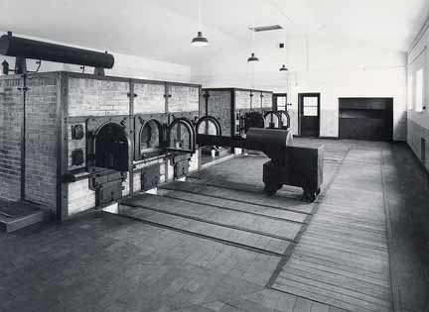
The Rise of Adolf Hitler
In January 1933, Adolf Hitler became chancellor, or prime minister, of Germany. Using propaganda posters, he stirred up anti-Semitism (or hatred towards Jews). These posters took advantage of existing stereotypes that the Jews loved money and had big noses. He called Jews “the enemy” and convinced Germans that they were a dirty, inferior race. Little by little, step by step, Jews were separated from their neighbors. In 1935, Hitler announced three new laws that stripped Jews of citizenship and made it a crime for Christians to have contact with them. Once he was firmly in control of Germany, Hitler attacked neighboring countries. By 1940, his soldiers, the Gestapo, had conquered most of Eastern and Western Europe. In each country, Jews were identified, isolated, stripped of all power, and ultimately singled out for murder. Hitler began with small edicts like forcing Jews to wear the Star of David to identify them. Then he made harsher rules. He isolated the Jews, forcing them to live in ghettos away from other citizens, which prevented them from finding help. Finally, they were shipped to death camps and concentrations camps in cattle cars called transports. By 1943, most of Europe’s Jews were either dead or on the way to concentration camps. The largest camp was Auschwitz-Birkenau.
Crematorium where Jews were burned.

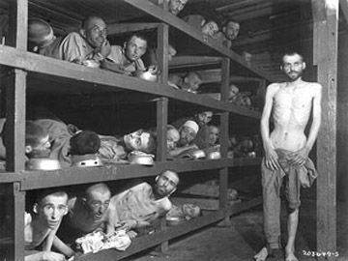
Life in the Concentration Camps
Concentration camps were work camps in which Jews were starved, worked, and burnt to death in large fire and gas chambers called crematoriums. Many Jews were burned as soon as they arrived at the camps because they were too young, old, or weak to work. The Jews that were forced to work lived crammed into small buildings called barracks or blocks and they were given small amounts of food each day, called their ration. There were frequent “selections” when the Nazis would pick out the weak or sick Jews and send them to the crematorium to be killed. Sometimes, the Nazis would make an example out of Jews who tried to stand up for themselves by publicly hanging them from gallows in the middle of the camps. The Nazis also chose Jews to be Kapos, Jewish police officers who were supposed to police and punish their own people. This terrible time did not end until 1945 when the Russians and Americans were finally able to put an end to World War II and Hitler’s reign of terror.
A barrack – housing Jews in concentration camps.

- A Jewish priest is called a ____________________________ or __________________________.
- Just as Christians have Sunday as their holy day, or _________________________, Jews’ holy day is_____________________________.
- Rather than worshiping in churches, Jewish people go to a _______________________________.
- The Jewish holy text is called the ______________________________ and it is extremely similar to the Christian Old Testament.
- _________________________ is an advanced form of Judaism that works to figure out the point of the life and the mysteries of the world.
- Someone who works and lives in a Jewish holy building is called a ____________________________.
- The Nazis forced the Jews to move to separate parts of the city called ______________________.
- The Jews were taken to the concentration and death camps in cattle cars called ______________________.
- In the concentration camps, the Jews were forced to do hard labor. They lived in ______________________ or ______________________ that had dozens of Jews all crammed together in bunk beds.
- The tiny amount of food Jews were fed each day was called their ______________________.
- Nazis killed Jews were too weak or sick to work. This was called ______________________.
- ______________________ was the largest concentration and death camp.
- The Nazis killed the Jews by burning them in the ______________________.
- ______________________ are things that are used to hang people.
- German soldiers are called _________________.
- A Jewish police officer was called a _________________ and was expected to ______________________________.

Prior knowledge (Not in the article, but you should know these):
- The German leader who started the Holocaust was named ______________________.
- The Holocaust happened between the years of ________ and __________.
- The Germans used ______________________________ posters to convince people that Jews were evil, less-than-human beings who should be treated like animals.

- These posters took advantage of pre-existing ______________________________ about the Jews, such as “Jews have big noses” and “Jews love money/are good at making money”.

- Once the Nazis took over, the Germans began to _________________________ the Jews by taking away their rights and keeping them from doing what they want to do.

Holocaust Short Answer:
- The purpose of the concentration camps was… (explain)

- How did Hitler take control of the Jews in Europe?

