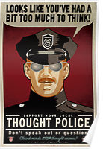
1984 and Brave New World Research Project

Both 1984 and Brave New World offer predictions for what our world could look like if we continue on the trends present in the 1930’s and 40’s. Some of the issues that they were concerned with were drugs, promiscuity, cloning, consumption, surveillance, communism, and autocratic leaders. In many ways, these issues are still present today, even advancing further towards the societies depicted in each book.

For this project, you will conduct research into the present state of American society and make a determination as to which prediction is more likely to occur. Which one more accurately depicts our world and where it is heading? Which trends are more concerning? Why?

In order to answer these questions, you will need to do the following:
- Find at least 3 current event articles that are related to the issues discussed in the books.
- Find at least one scholarly article that deals with one of the issues discussed in the books.
- Write a 3-4 page paper answering the questions above, using the evidence found in the articles and quotes from the books as support.
  - The paper should include at least one counter argument paragraph where you address the argument for the other book.
  - Include a works cited page that accurately lists all of your sources. There should be 5-6 sources (your four articles and your book of choice. If you quote the other book, you need to list that one as well).

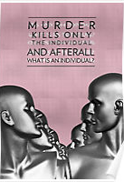
- For the final aspect of the project, you will create a poster that warns the public of where we might be heading. Consider: Which trend in our world is most likely to lead us into one of the societies of the book? Then, consider what can be done in order to halt our march towards the dystopias of 1984 and Brave New World.

  - Your poster should include both the warning about the problem, and a suggestion for how to fix it.
  - Your posters can be created digitally, but they must be put together on a poster board that is larger than 8.5” by 11”.
  - These posters will be hung up around the school, so please make sure that the pictures and words are still school appropriate.
  - You will be presenting these posters, so make sure that you can clearly articulate what the poster represents and how it is trying to warn the public.

