University Of Chicago Tells Freshmen It Does Not Support 'Trigger Warnings'
August 26, 20164:29 PM ET
Heard on All Things Considered
David Schaper
The University of Chicago is welcoming new students to campus by warning them that they might hear things that might make them uncomfortable.
A letter sent by the school this week tells incoming freshmen that the university does not support "trigger warnings" as part of its commitment to freedom of expression.
"Dear Class of 2020 student," the welcome letter from the school's Dean of Students John Ellison begins. It goes on to explain the university's commitment to freedom of expression and inquiry. Students "are encouraged to speak, write, listen, challenge and learn without fear of censorship."
In a welcome letter to freshmen, the College made clear that it does not condone safe spaces or trigger warnings: pic.twitter.com/9ep3n0ZbgV
— The Chicago Maroon (@ChicagoMaroon) August 24, 2016
And that means the school "does not support so-called 'trigger warnings' " to alert students of upcoming discussions or speakers that they might find offensive.
The University of Chicago won't cancel controversial speakers, and it "does not condone the creation of intellectual 'safe spaces' where individuals can retreat from ideas and perspectives at odds with their own."
Law professor Geoffrey Stone says the letter's intent was based on a report from a faculty committee he chaired on freedom of expression and academic freedom.
"This is really exciting," Stone says. "You're coming to an amazing institution."
He says the University of Chicago has a long history of standing for those principles.
"We've been deeply committed to the notion that we're here to learn from one another and to learn from the world and to study things and to figure out the answers. And the best way to do that is to hear all sides of everything."
Political science professor Charles Lipson shares his colleague's enthusiasm.
"I think it's an excellent thing," says Lipson, adding that too many campuses are shutting down discussions or speeches that some might find uncomfortable or offensive.
Across town, for example, DePaul University canceled an event last spring with conservative blogger Milo Yiannopoulos after his talk was disrupted by protests. Lipson notes several other schools have had similar controversies.
"I think universities have allowed students and faculty who want to suppress speech free rein," he says. "They've rolled over and they have not stood up for what ought to be a basic value of universities, which is to encourage free speech."
On campus, the challenge to hear and share different points of view is exactly what 16-year-old prospective student Ellie Carter from Ashland, Ore., is looking for.
"I can't understand why a college campus would be the kind of place where people would police uncomfortable topics or topics that should be," Carter says. "This is the place that they should be having that discussion at."
Carter's mom, Kathy, agrees.
"I want her exposed to more things, not to less things," Kathy says.
But the Carters also say trigger warnings can be important on some topics for some students. And that's a concern of graduate student Kelsey Stilton as well.
"It's a little in-your-face for the very first day of school," Stilton says.
She wishes the administration chose better terminology to reflect its commitment to free speech.
"The word 'trigger warning' and the word 'safe space' also implies something for people that have been in abusive or traumatic situations," she adds.
University of Chicago officials say professors still can provide trigger warnings and safe spaces if they choose, and they promise a lot more discussion when students arrive on campus and classes begin at the end of next month.

Half Of Professors In NPR Ed Survey Have Used 'Trigger Warnings'
September 7, 20164:39 PM ET
Heard on All Things Considered
Anya Kamenetz
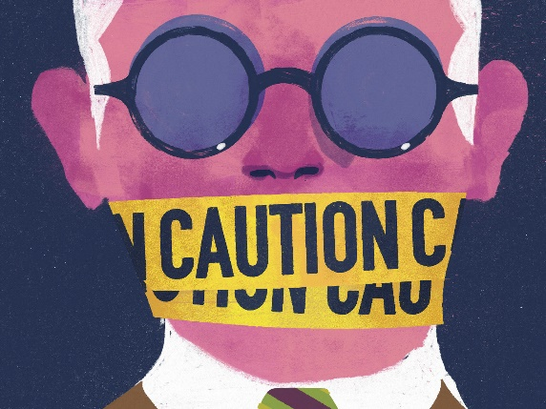
Keith Negley for NPR
This school year, the University of Chicago has put the debate over "trigger warnings" on campus back in the news. The University told incoming freshmen that, because of its commitment to freedom of expression, it does not support warnings to students about potentially difficult material.
But amid all the attention to trigger warnings, there have been very few facts about exactly how common they are and how they're used.
NPR Ed sent out a survey last fall to faculty members at colleges and universities around the country. We focused specifically on the types of institutions most students attend — not the elite private universities most often linked to the "trigger warning" idea.We received more than 800 responses, and this month as the issue once again made headlines we followed up with some of those professors.
Here are some of our key findings:
- About half of professors said they've used a trigger warning in advance of introducing potentially difficult material.
- Most said they did so of their own volition, not because of a student's request or an administrative policy.
This was not a scientific sample, but it's one of the larger and more representative polls to be published on the topic to date.
Our sample included 829 instructors of undergraduates. Just over half of our respondents, 53.9 percent, said they teach at public four-year institutions and 27 percent said they were at two-year institutions.
These instructors were overwhelmingly familiar with trigger warnings: 86 percent knew the term and 56 percent said they had heard of colleagues who had used them.
But only 1.8 percent said, as of last fall, that their institutions had any official policies about their use.
Let's define terms.
The term "trigger" in this sense originates in psychology, where it pertains to people with a diagnosis of post-traumatic stress disorder. For survivors of combat violence, sexual abuse or other trauma, certain sights, sounds, smells or other reminders can bring on intense emotional and even physical reactions, like a full-blown panic attack.
In the media and elsewhere online, language similar to trigger warnings is often used more broadly to label material that concerns sexual abuse or sexual assault, that is potentially racially or politically offensive, or graphically violent or sexual. For example, when NPR covered the fatal shooting by police of Philando Castile, an African-American resident of the Minneapolis area, we included these words: "We'll embed the video here, with the warning that it contains images and language that viewers might find disturbing."
But the rules are different in a college classroom than in a therapeutic setting, and both are different than when addressing a general audience. Even some of our respondents who had supplied a form of trigger warning as a "courtesy" or "heads-up" said they didn't intend to give students a free pass to avoid uncomfortable topics.
In fact, the picture that emerges is of professors making private decisions within the four walls of the classroom. Only 3.4 percent said students had requested such a warning. Most instructors who told us they'd used trigger warnings — 64.7 percent — did so because, they said, "I thought the material needed one."
So what are the types of material that are most likely to trigger a trigger warning?
Our respondents were most likely to say they had used trigger warnings in reference to sexual or violent material. Racially, politically, or religiously charged topics were mentioned less often.
"I have had students break down reading novels depicting sexual assault and incest in my gender studies courses," a professor at the University of North Carolina said in a survey response.
Joanna Hunter, who teaches sociology at Radford University in Virginia, told NPR Ed last week that she has given a warning before explaining the practice of female genital mutilation, within the broader context of a discussion of cultural relativism.
Lauren Griffith, a professor of ethnology at Texas Tech University, said that she gave warnings when teaching Native American students whose religious beliefs required that they undergo a form of ritual purification upon viewing images of death. However, she says, outside of such specific situations, she doesn't believe that trigger warnings best serve the cause of liberal education: "I think that trigger warnings can and should be used in a limited number of situations, but overusing them can create a situation in which students opt out of learning experiences simply because they don't want to confront their own assumptions about the world."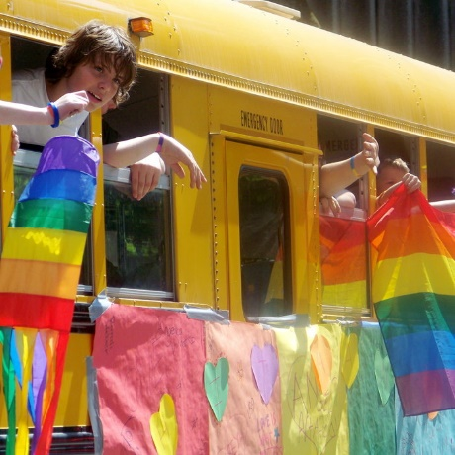
Hasan Jeffries, an associate professor of history at Ohio State University, said in an interview that heavy emotions — even tears — are parts of the learning process that he welcomes. He teaches African-American and U.S. history.
He tells his students at the beginning of each course, "This is hard history. It's hard to talk about, hard to absorb. It's filled with trauma, sexual violence, racial violence, visual images of murder and chaos. You may walk into my classroom and see an image of a lynching that was put on a postcard. This is America."
At the same time, he adds, he's sensitive to the fact that many of his students may have experienced, say, sexual assault or police violence in their personal lives.
"I understand and take seriously trauma triggers," Jeffries says. "I'm not hostile to one side or the other and I don't think there's an absolute position."
None of the professors we talked to said that they had had a student try to get out of an assignment or skip a class because of topics that made them uncomfortable. The most common response to a warning was either nothing at all, or at most, for a student to excuse him or herself from class for a few minutes.
Jeffries, like other faculty members, told us that his department had ultimately decided against issuing an official position on the use of trigger warnings: "The general consensus was, we're not really interested in putting those forward. We feel confident in ourselves as teachers and in the maturity of our students."
Meg Anderson contributed to this report.
Questions to answer. Please make sure that you fully answer each question (your answers should have more than 4 sentences each).
- Do you think the University of Chicago made the right decision in getting rid of trigger warnings?
- Do you think college campuses should use trigger warnings for potentially traumatic or disturbing material? Should they be required? Should they be banned? Why or why not?
- Should speakers be banned from a school if they are radically opposed to the mindset and perspective of most of the people on campus? Is this a form of free speech or censorship? Why?
- Write your own level 3 question and answer it.

