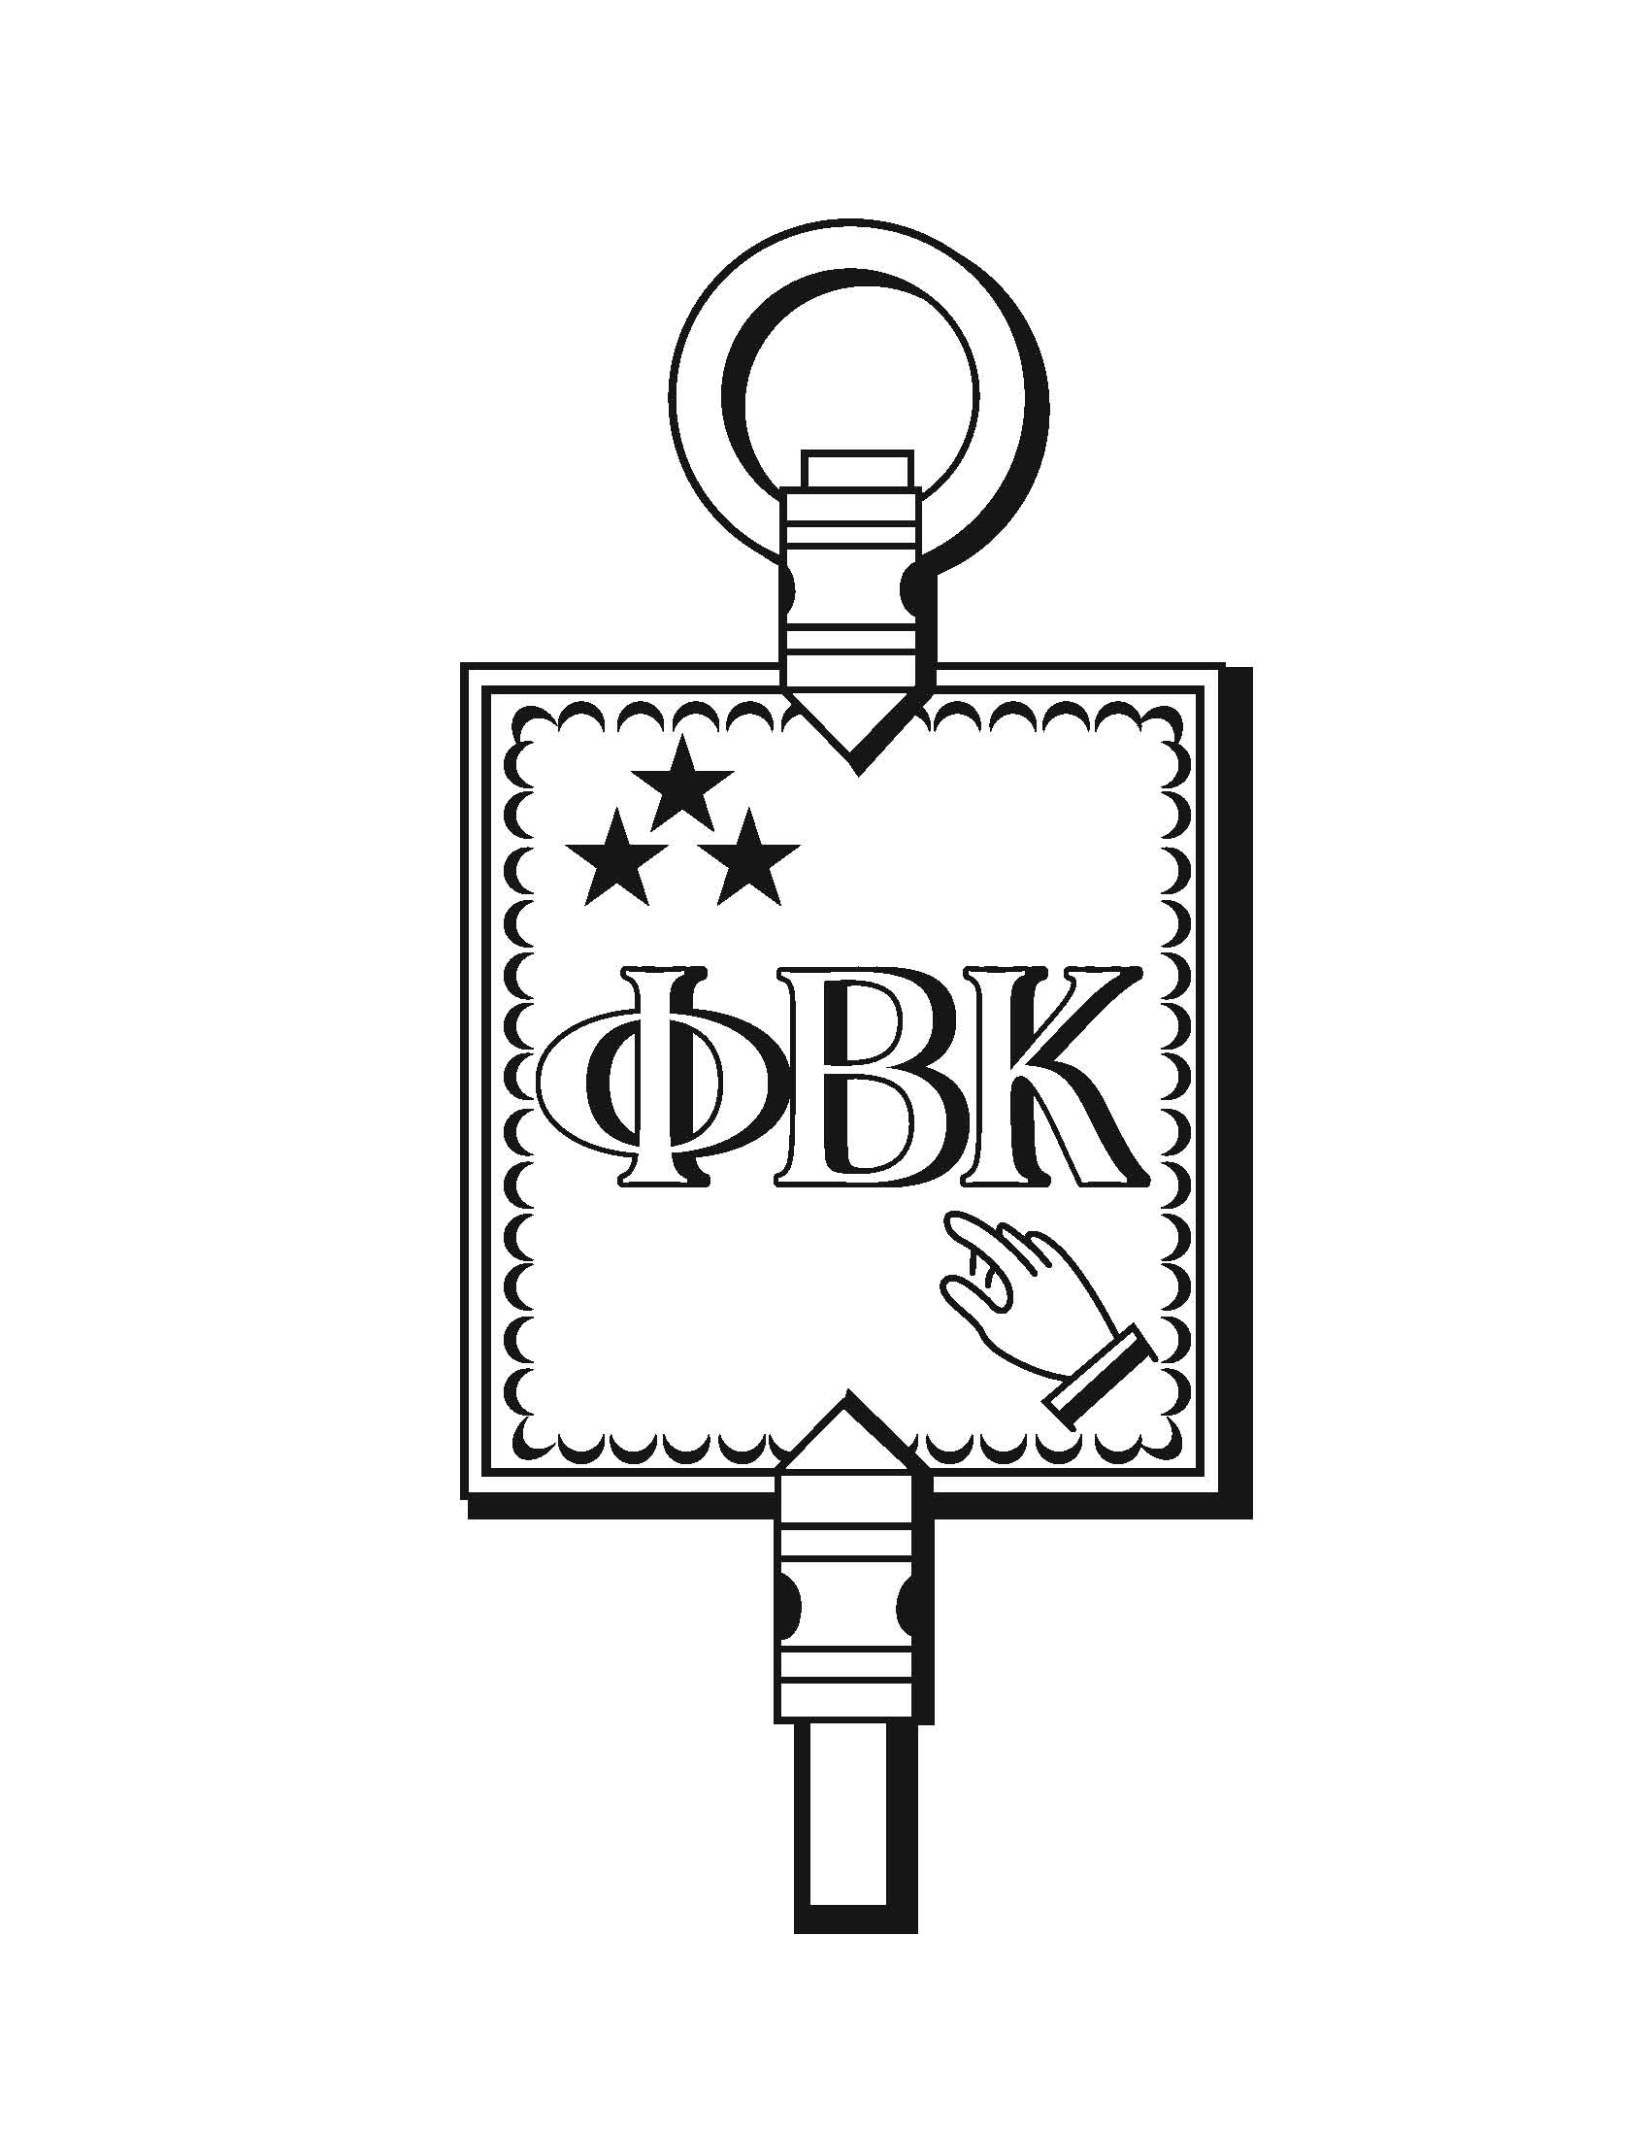
Announcing
The 2016 PHI BETA KAPPA WRITING CONTESTS
Sponsored by the Phi Beta Kappa Association
of Wake County
NEW DEADLINE: March 8, 2016

Eligibility: All juniors and seniors in public and private Wake County schools
Type of Composition:
The composition must be a literary analysis that is a close reading and interpretation of a literary text. The use of secondary sources with appropriate citations is encouraged but not required. The essay must be part of the regular work of an English class and must be submitted with the student’s permission. Students should carefully polish the essay after it has been graded, responding thoughtfully to their teachers’ feedback.

Judges’ criteria: Our readers look for strong critical thinking, originality of insight, mastery of language, appropriate use of secondary sources (if used), and attention to citation conventions.

Form of entry:
Two hard copies of each entry must be submitted.
Entries must be typed and double-spaced; pages must be numbered.
Critical and biographical sources and quotations must be correctly documented.
The essay should be carefully proofread.
Any teacher’s marks or comments must be removed.
The title of the essay should be at the top of the first page.
The student’s name must not appear on any page of the essay.
A cover sheet must be attached to each copy of the essay. The cover sheet should give the following information: essay title, student’s name, student’s grade level,
teacher’s name, school’s name, address, and telephone number for the teacher

Number of entries: Only one entry is allowed for each student. Teachers of all eligible classes may select and submit no more than five essays per grade level.

Submitting: Mail or deliver essays to:
Dana Lindquist
1908 Prescott Place
Raleigh, NC 27615
Questions: Dana Lindquist 919-306-4262 or d.lindquist@icloud.com

Awards: Winners will be recognized at the PBK spring banquet in April. First place winners receive $500, a gift-certificate to Quail Ridge Books, and a certificate of merit; second-place winners receive $250, a gift-certificate to Quail Ridge Books, and a certificate of merit. Honorable mention will receive $100.

