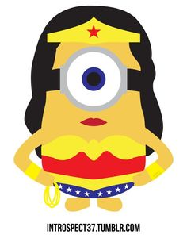
Hero Character Sketch
Class Character
- Gender:
- Age:
- Super hero quality:

- Name:
- Physical characteristics

- Any other way they are different from others?

- How do they show that they want to do good? How do they work to fight evil?

- Why do they want to do good? (Do they have some sort of loss that has motivated them to fight evil?)

- What kind of sacrifice have they made, or will make? What have they given up to be this other worldly figure?

Hero Character Sketch
Individual Character
- Gender:
- Age:
- Super hero quality:

- Name:
- Physical characteristics

- Any other way they are different from others?

- How do they show that they want to do good? How do they work to fight evil?

- Why do they want to do good? (Do they have some sort of loss that has motivated them to fight evil?)

- What kind of sacrifice have they made, or will make? What have they given up to be this other worldly figure?

