No Appetite for Good-for-You School Lunches
By VIVIAN YEEOCT. 5, 2012
Photo
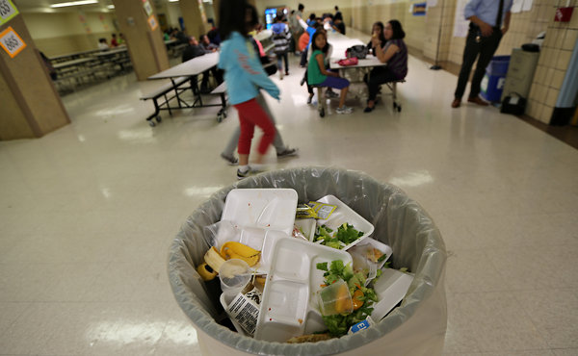
Outside Pittsburgh, they are proclaiming a strike, taking to Twitter and Facebook to spread the word. In a village near Milwaukee, hundreds staged a boycott. In a small farming and ranching community in western Kansas, they have produced a parody video. And in Parsippany, N.J., the protest is six days old and counting.
They are high school students, and their complaint is about lunch — healthier, smaller and more expensive than ever.
The Healthy, Hunger-Free Kids Act of 2010, which required public schools to follow new nutritional guidelines this academic year to receive extra federal lunch aid, has created a nationwide version of the age-old parental challenge: persuading children to eat what is good for them.
Because the lunches must now include fruits and vegetables, those who clamor for more cheese-laden nachos may find string beans and a peach cup instead. Because of limits on fat and sodium, some of those who crave French fries get baked sweet-potato wedges. Because of calorie restrictions, meat and carbohydrate portions are smaller. Gone is 2-percent chocolate milk, replaced by skim.
“Before, there was no taste and no flavor,” said Malik Barrows, a senior at Automotive High School in Brooklyn, who likes fruit but said his classmates threw away their mandatory helpings on the cafeteria floor. “Now there’s no taste, no flavor and it’s healthy, which makes it taste even worse.”
Students organized lunch strikes in a suburb of Pittsburgh, where in late August the hashtag “brownbagginit” was trending on Twitter, and outside Milwaukee, where the Mukwonago High School principal, Shawn McNulty, said participation in the lunch program had fallen 70 percent.
“There is a reduction in nacho chips, there is a reduction in garlic bread, but there’s actually an increase in fruits and vegetables,” Mr. McNulty said. “That’s a tough sell for kids, and I would be grumbling, too, if I was 17 years old.”
In New Jersey, more than 1,200 people have joined a Facebook group that urges Parsippany Hills High School students to boycott the school lunches. Despite the enticement of a Chinese-themed lunch a week ago Friday, the first day of the strike, only a few students bought anything from the cafeteria, according to the strike organizers.
The set lunch that cost $2.50 last year now costs $2.60. The cafeteria still offers pizza, French fries and chicken nuggets, but all of the servings have shrunk. And the packaged baby carrots and apples that each student must take before leaving the lunch line usually end up in the trash, said Brandon Faris, a boycott organizer.
“Everybody in the school’s like, ‘Have you seen the lunch prices? It’s ridiculous!’ ” said Brandon, who derided the Chinese food as a “bribe.” “The portion of the meal went down; the price should also go down.”
According to the new restrictions, high school lunches must be no more than 850 calories, middle school lunches no more than 700 calories and elementary school lunches no more than 650. Before, there were no maximums.
At the same time, prices have gone up about 10 cents in many districts for students who do not qualify for free lunch, both to pay for fresh fruits and vegetables and to obey a federal requirement that lunch prices gradually increase to help cover their cost.
In Sharon Springs, Kan., lunch protesters at Wallace County High Schoolposted a video on YouTube, “We Are Hungry”; in it, students faint in the hallways and during physical education class, acting as if they had been done in by meager helpings of potato puff casserole and chicken nuggets. To the tune of the song “We Are Young” by Fun, one student on the video sings, “My friends are at the corner store, getting junk so they don’t waste away.”
Since it was uploaded three weeks ago, “We Are Hungry” has had nearly 900,000 views.
Callahan Grund, a junior who stars in the video, said, “My opinion as a young farmer and rancher is that we produced this protein and it’s not being used to its full advantage.” He wakes up early every morning to do chores, stays after school for two hours of football practice and returns home for another round of chores. If it were not for the lunches his mother now packs him, he said, he would be hungry again just two hours after lunch.
In New York City, where school officials introduced whole-wheat breads, low-fat milk and other changes several years ago, the most noticeable change this year is the fruit and vegetable requirement, which has resulted in some waste, according to Eric Goldstein, the Education Department official who oversees food services. It is not hard to see why. At Middle School 104 in Gramercy Park on Friday, several seventh graders pronounced vegetables “gross.”
“I just throw them out,” said Danielson Gutierrez, 12, carrying a slice of pizza, which he had liberally sprinkled with seasonings, and a pear. He also offered his opinion on fruit: “I throw them out, too. I only like apples.”
Courtney Rowe, a spokeswoman for the United States Department of Agriculture, which sets school food regulations, said that despite the complaints about lighter lunches, federal audits showed the average high school lunch before this year contained only 730 calories, less than the minimum number of calories they must now contain, 750.
Of course, students may not be eating all the calories they are being served, though Ms. Rowe noted that in most schools, students have the option of buying additional food à la carte.
Sandra Ford, president of the School Nutrition Association, said food service directors were using a variety of strategies to get students to embrace the new menus, including asking teachers to talk about healthy food in class, conducting taste tests, handing out free samples and educating students about how their food is grown and made.
But the most effective strategy, several food service directors said, may simply be waiting. Research shows that children must be exposed to vegetables 10 to 12 times before they will eat them on their own, said William J. McCarthy, a professor of public health and psychology at the University of California, Los Angeles.
“If our task is to get young kids to eat more fruits and vegetables, we have to be willing to put up with the waste,” he said.
Few school districts have been as extreme in their efforts as Los Angeles, which introduced a menu of quinoa salads, lentil cutlets, vegetable curry, pad Thai and other vegetarian fare last fall. When students began rejecting the lunches en masse, the district replaced some of the more exotic dishes with more child-friendly foods, like pizza with whole-wheat crust, low-fat cheese and low-sodium sauce.
But this year, even the whole-wheat pizza is gone, replaced by calzones, fajitas and other, smaller entrees with side dishes of fruits and vegetables.
Nicole Anthony, the cafeteria manager at one Los Angeles school, Nimitz Middle School in Huntington Park, estimated that out of the 1,800 students, almost all of whom qualify for a free or reduced-price lunch, only 1,200, “on a good day,” now eat the cafeteria’s offerings.
Ms. Anthony is not optimistic that the students will warm to their new lunches anytime soon — not as long as they can buy Flamin’ Hot Cheetos from the vending machines or brownies from the student store for lunch.
“Why would I come over here for a chicken and apple when I can get a cookie and some Gatorade and some gummies?” she said. “What would you choose?”

