OPINION

Charlie Hebdo free speech debate: Nobody is listening

The chilling attacks sparked a global debate about free speech and the right to offend.
14 Jan 2016 13:44 GMT | Politics, Media, Human Rights, Racism, France
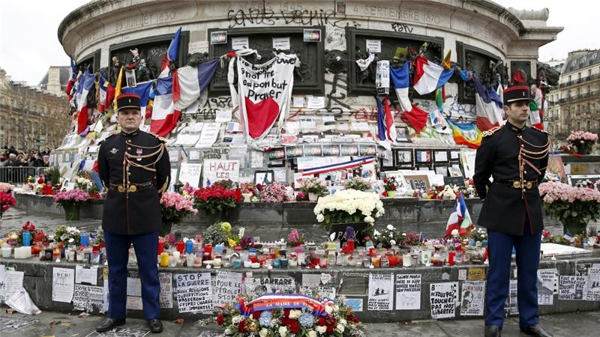French Republican guards on duty during a ceremony paying tribute to the victims of last year''s shooting at Charlie Hebdo [REUTERS]

ABOUT THE AUTHOR

Rachel Shabi
Ironically, in the recently revived debate over free speech, there has been a paucity of real, engaged communication - you know, the type where you actually listen to the people with whom you think you disagree.
The commentary has come up around the one-year commemoration of the Charlie Hebdo massacres, in which jihadist gunmen killed 12 people at the satirical magazine in Paris and then shot four hostages at a kosher supermarket as well as a policewoman.
Those chilling attacks sparked a global debate about free speech and the right to offend (although, as the magazine's chief editor Gerard Biard noted, there was worryingly less debate over the killing of four Jewish peoplein a kosher supermarket).
Now, one year on, the declaration that we are all Charlie - Je Suis Charlie - is still strong. And it is still often accompanied by an assumption that not showing solidarity in this particular way is somehow synonymous with saying those 10 cartoonists deserved to be murdered.

Unable to be Charlie
As the British political website politics.co.uk reported last week, French Muslims felt unable to "be" Charlie because the perception of Islamophobia creeping out of those cartoons was turned into a kind of litmus test for national loyalty.
Index on Censorship's France correspondent, Valeria Costa-Kostritsky, told the site: "What we witnessed was a discussion with two trends emerging - those who were Charlie and those who weren't. After the terror attack it was very problematic to not be Charlie, or to express some distance or criticism of the work of Charlie Hebdo."
The "Je Suis Charlie" argument seems to be that support for the magazine's brand of satire cannot be conditional - because, by definition, you cannot conditionally support free speech.
Well, OK, but what if people are constantly telling you that they condemn the killings and still cannot "be" Charlie - what then?
We cannot credibly dismiss that many do find Charlie Hebdo racist and Islamophobic - those arguing that, rather than using satire to challenge the powerful, punching upwards, the magazine instead targets an already marginalised Muslim minority, punching downwards. The point obviously relates to the effect that this might have on a societal level - creating or stoking animosity towards a weak community.
Regardless of whether or not you agree, there is no point trying to stem such critiques - because you can't defend free speech by curtailing how that free speech is received (as long as the reception is not violent). Satire, in some luckier countries, is viewed as an essential tool for challenging and questioning power, a position that has been fiercely fought for and which should be fiercely defended.

Necessary debate
But that doesn't change the fact that some of it is just really bad, or clumsily deployed, or may be received by weaker groups as a proxy for attacking them. There are all kinds of reasonable counters to these arguments: you could point out that Charlie Hebdo attacks powerful, organised religions (all of them), rather than the individually religious; or you might find it a bit patronising to assume that minority communities are so terribly sensitive.
But still, describing cartoons as offensive or unhelpful, or as misusing their position, is all a part of the necessary debate that satirists both raise and should be prepared to face. And, crucially, that's the bit we can't shut down following the actions of murderous extremists - who do not get to shape or define this conversation.
At the same time, there are problems with an insistence of free speech in western societies at a time when such freedoms are clearly qualified by those countries in question.
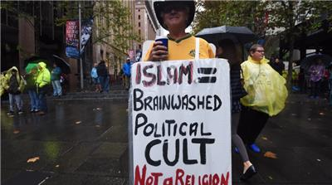
Protesters supporting the 'Reclaim Australia' group hold anti-Muslim placards during a protest rally in Sydney, Australia [EPA]
Speech wasn't free for the eye-wateringly offensive, anti-Jewish ranting French comedian Dieudonne, who was arrested for being an apologist for terrorism after posting to his Facebook page: "I feel like Charlie Coulibaly" (merging the cartoon with one of the men who took hostages in the Paris kosher supermarket).
Neither was it free for the French pro-Palestinian protesters whosedemonstrations against Israel's assault in Gaza in 2014 were banned.
Meanwhile, those emergency powers declared in the aftermath of the Paris attacks have since been continually extended and now - following November's heinous multiple terror attacks, in which 120 people were killed - look like they may be kept in place indefinitely.

READ MORE: Why don't we care about anti-Muslim abuse?

It is these laws that allowed the French state to stop climate change protesters during the summit on the subject in December last year. Those same powers have been used to stop and search scores of people, most of them Muslims, as well as to detain without charge.
During the week-long commemoration of the Charlie Hebdo attacks, free speech organizations around the world, spearheaded by the writers' group Pen International, pointed out that the biggest threats to free speech came from governments "ostensibly motivated by security concerns".
Pen's statement on the issue drew critical attention to France's new surveillance laws - which have elsewhere been condemned by human rights groups as being too intrusive and carrying no judiciary control.
And, while free speech is the foundation stone of a progressive, functioning democracy we can't champion it in isolation, while losing sight of other key principles. The democracies whose politicians insist that we are all Charlie are the same ones chipping away at other freedoms. What of the suggestions of passport-stripping coming from both French and British governments - for dual-nationality terrorism convicts and those returning from fighting with ISIL, respectively? This might be one of the most anti-democratic things a state can do, flying in the face of the fundamental right to citizenship by birth.
It's only when we get rid of what one writer has described as "discursive segregation" in the context of free speech and Charlie Hebdo, that we can start to fight for and uphold these invaluable collective rights, together. It's the capacity to fight for two seemingly opposing things at the same time that we need to find - because, until we do, how will we ever find the operational common ground between them?
Rachel Shabi is a journalist and author of Not the Enemy: Israel's Jews from Arab Lands.
The views expressed in this article are the author's own and do not necessarily reflect Al Jazeera's editorial policy.

British Muslims gather in London to protest against Muhammad cartoons

Press Association
Sunday 8 February 2015 12.52 EST
Thousands of British Muslims gathered near Downing Street to protest against cartoons showing the prophet Muhammad and voice opposition to “insulting” depictions.
A leaflet issued by the Muslim Action forum (MAF), who organized the rally, said recent republishing of cartoons, caricatures and depictions of Muhammad by satirical magazine Charlie Hebdo and other publishers is a “stark reminder” that freedom of speech is “regularly utilized to insult personalities that others consider sacred”.
The group also expressed “deep regret” at the Paris terror attacks, which included a massacre at Charlie Hebdo, saying they were a “violation of Islamic law”.
The words “Charlie and the abuse factory” and “learn some manners” were written on signs held by demonstrators. A number of speakers addressed the crowd while there were communal prayers before a delegation took a petition signed by more than 100,000 British Muslims to 10 Downing Street.
It calls for “global civility” and says the production of cartoons of the Prophet Muhammad are “an affront to the norms of civilised society”.
Shaykh Tauqir Ishaq, a senior spokesman for MAF, said: “Perpetual mistakes by extremists, either by cold-blooded killers or uncivilised expressionists, cannot be the way forward for a civilised society. The peace-loving majority of people must become vociferous in promoting global civility and responsible debate. At this time of heightened tension and emotion, it is crucial that both sides show restraint to prevent further incidents of this nature occurring.”
Shaykh Noor Siddiqi, another MAF representative, said: “The actions of the UK media in not publishing the cartoons is highly appreciated by British Muslims and we hope that this kind of self-restraint and mutual respect will ultimately lead to a harmonious society.”
Across the street on Whitehall a handful of counter demonstrators holding a Britain First banner gathered.
Scotland Yard said it was not aware of any arrests during the protest.

Charlie Hebdo Article

Directions: Answer each of these questions and be prepared to discuss them with your classmates. Then, write one question of your own.

- Do you think that Charlie Hebdo, or any other magazine or website, should publish articles that are so offensive to religious Muslims? Or Christians? Or Americans? Why or why not?

- Do you think the government should force them to stop printing those things? Why or why not?

- Are there limits to free speech? Do you think anyone should be able to say anything to anyone at any time? Why or why not?

- Do you think the government should be able to stop people from saying, printing, or shouting (in protest) something that could incite violence?

